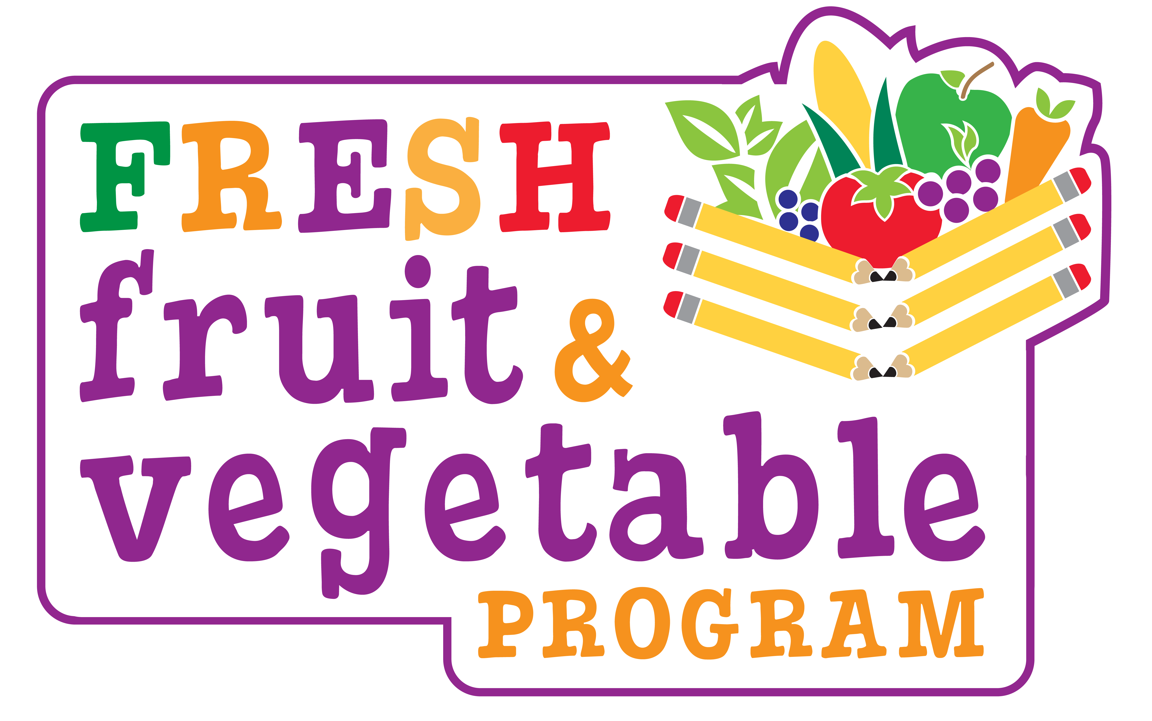

SAMPLE

Dear Teachers & Staff:

Our school will be participating in a special Fresh Fruit and Vegetable Program for the current school year. We will be offering fresh fruits and vegetables in the classroom as snacks. We are excited and privileged to have been awarded this grant to provide our _(Name of School)_ students with healthy, nutritious foods. The NJ Department of Agriculture awarded this program to a limited number of schools throughout the state.

_(# of Days)_ days each week your students will enjoy a fruit or vegetable in the classroom. Please do not allow students to take these items home! For this program to be a success we are asking for your help. This snack should be a classroom experience shared among peers.

We need you to be role models by implementing the following:

- Join in with your students and eat the fruit or veggie snack.

- Highlight the importance of eating nutritious fruits and veggies.

- Emphasize trying veggies even though your students may think they’re “nasty.” Motivate your students to take a small taste.

- Be positive about eating raw veggies you may commonly consume as a cooked food.

- Encourage your students to eat fruits and veggies at home during mealtimes and for snacks.

The goals of the fruit and vegetable program are as follows:
- Increase children’s fruit & vegetable consumption.
- Create healthier schools.
- Promote wellness.
- Encourage nutritious food choices to have an impact on future health.

We hope you will extend these goals in your classroom. This program will benefit the health and well-being of our students! Students look up to you. As their teacher and adult role model you can make a difference in their future health. Please support this program and make our school shine! Thank you for your support!

__________________________
Principal

